CAPSTONE PROJECT REPORT
(Project Term January-May 2023)

AI‐Enabled Smart Hardware System for Image‐Based Municipal Waste Classification and Segregation

Submitted by

Mungalpara Chetan Pravinbhai Registration Number : 12207641
Subhash Suthar Registration Number : 12215865
Krishna Pradhan Registration Number : 12224021
Shashi Kant Kumar Registration Number : 12214125
Gaurav Kumar Sahu Registration Number : 12216579
Vishal Biswakarma Registration Number : 12206477

Project Group Number : 2RGC0887
Course Code : CSE439

Under the Guidance of

Dr. Manjot Kaur (Associate Professor)

School of Computer Science and Engineering


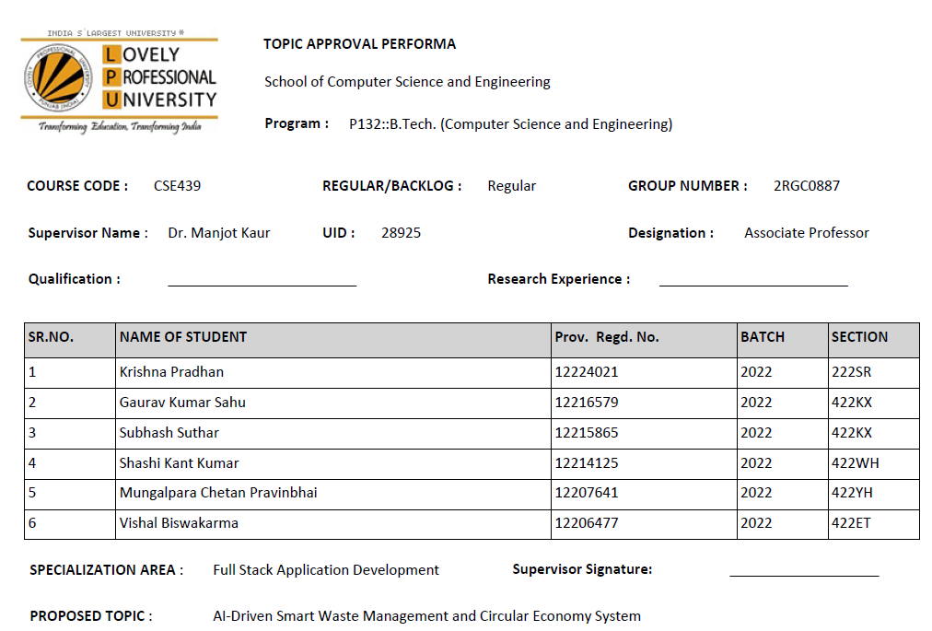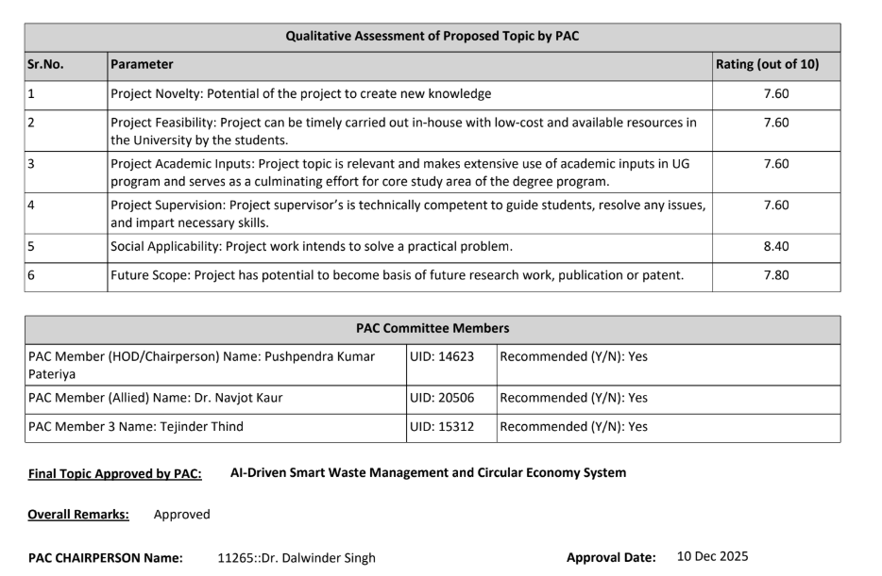
DECLARATION
We hereby declare that the project work entitled AI‐Enabled Smart Hardware System for Image‐Based Municipal Waste Classification and Segregation is an authentic record of our own work carried out as requirements of Capstone Project for the award of B.Tech degree in Computer Science and Engineering from Lovely Professional University, Phagwara, under the guidance of Dr. Manjot Kaur, during August to November 2022. All the information furnished in this capstone project report is based on our own intensive work and is genuine.
Project Group Number: 2RGC0887
Name of Student 1: Mungalpara Chetan Pravinbhai
Registration Number: 12207641
Name of Student 2: Subhash Suthar
Registration Number: 12215865
Name of Student 3: Krishna Pradhan
Registration Number: 12224021
Name of Student 4: Shashi Kant Kumar
Registration Number: 12214125
Name of Student 5: Gaurav Kumar Sahu
Registration Number: 12216579
Name of Student 6: Vishal Biswakarma
Registration Number: 12206477
(Signature of Student 1)
Date:

(Signature of Student 2)
Date:

(Signature of Student 3)
Date:

(Signature of Student 4)
Date:

(Signature of Student 5)
Date:

(Signature of Student 6)
Date:

CERTIFICATE
This is to certify that the declaration statement made by this group of students is correct to the best of my knowledge and belief. They have completed this Capstone Project under my guidance and supervision. The present work is the result of their original investigation, effort and study. No part of the work has ever been submitted for any other degree at any University. The Capstone Project is fit for the submission and partial fulfillment of the conditions for the award of B.Tech degree in Computer Science and Engineering from Lovely Professional University, Phagwara.

Signature and Name of the Mentor

Designation

School of Computer Science and Engineering,
Lovely Professional University,
Phagwara, Punjab.

Date :
TABLE OF CONTENTS
Inner first page……………………………………………………………………….(i)
PAC form……………………………………………………………………………(ii)
Declaration…...……………………………………………………………………..(iii)
Certificate……..…….………………………………………………………………(iv)
Table of Contents……………………...……………………………………………(v)

1. INTRODUCTION 1

1.1. BACKGROUND OF THE STUDY 1

1.2. THE CORE PROBLEM 1

1.3. PROPOSED SOLUTION 1

1.4. OBJECTIVES OF THE PROJECT 2
2. PROFILE OF THE PROBLEM 3
2.1. RATIONALE OF THE STUDY 3
2.2. PROBLEM STATEMENT 3
2.3. SCOPE OF THE STUDY 3
3. EXISTING SYSTEM 4
3.1. INTRODUCTION 5
3.2. EXISTING SOFTWARE AND HARDWARE SOLUTIONS 5
3.3. DATA FLOW DIAGRAM (DFD) FOR THE PRESENT SYSTEM 5
3.4. WHAT’S NEW IN THE SYSTEM TO BE DEVELOPED 6
3.4.1. SWITCHING FROM IMAGE CLASSIFICATION TO OBJECT DETECTION (YOLOV8) 6
3.4.2. THE CIRCULAR ECONOMY WEB DASHBOARD 7
4. PROBLEM ANALYSIS 7
4.1. PRODUCT DEFINITION 7
4.2. FEASIBILITY ANALYSIS 7
4.2.1. TECHNICAL FEASIBILITY 8
4.2.2. ECONOMIC FEASIBILITY 8
4.2.3. OPERATIONAL FEASIBILITY 8
4.3. PROJECT PLAN 8
5. SOFTWARE REQUIREMENT ANALYSIS 9
5.1. INTRODUCTION 9
5.2. GENERAL DESCRIPTION 9
5.3. SPECIFIC REQUIREMENTS 10
5.3.1. HARDWARE REQUIREMENTS 10
5.3.2. SOFTWARE REQUIREMENTS 10
6. DESIGN 11
6.1 SYSTEM DESIGN 11
6.2 DESIGN NOTATIONS 11

1. INTRODUCTION

1.1 BACKGROUND OF THE STUDY
As cities in India grow faster every year, managing municipal solid waste has become a massive challenge. Urban areas produce thousands of tons of garbage daily, and local infrastructure often struggles to keep up. The most critical step in waste management is segregation at the source-separating organic matter, recyclables, hazardous materials, and e-waste before they ever reach a landfill. When waste is mixed, it loses its recycling value and directly contributes to environmental pollution, soil degradation, and greenhouse gas emissions.
Despite government campaigns like the Swachh Bharat Mission and the placement of color-coded bins in public spaces and university campuses, actual segregation at the source remains very low. People often ignore the labels on bins out of habit or confusion, throwing plastic bottles into the organic bin and vice versa.

1.2 THE CORE PROBLEM
Currently, most municipal systems rely heavily on manual sorting after the waste is collected. We cannot continue to rely on manual sorting because it is slow, prone to human error, and exposes sanitation workers to serious health hazards, including toxic chemicals and sharp medical waste.
Some "smart" bins exist in the market, but most only use basic ultrasonic sensors to open the lid when a person approaches. They do not actually check what the person is throwing away. Because of this, the waste still gets mixed up inside the bin. We realized that to actually solve the problem, the bin itself needs to act as an automated gatekeeper that physically sorts the garbage using computer vision.

1.3 PROPOSED SOLUTION
To address these limitations, our group engineered the "AI-Driven Smart Waste Management and Circular Economy System." This project physically stops mixed waste at the source using artificial intelligence.
Instead of relying on the user to pick the right bin, our system does the thinking for them. The user simply places their trash in front of an attached webcam. A Python script captures the live video feed and passes it to a YOLOv8 object detection model. We specifically chose YOLOv8 instead of basic image classification because we needed the AI to identify multiple independent pieces of waste at the exact same time. If a user holds up a plastic bottle and a battery together, the system draws independent bounding boxes around each item, identifying one as "Recyclable" and the other as "Hazardous."
Once the AI classifies the waste, it sends a serial command to an Arduino microcontroller. The Arduino then activates the specific servo motor attached to the correct compartment (Organic, Recyclable, Hazardous, or E-waste), allowing the item to fall into the right place.
To take this a step further and introduce the "Circular Economy" aspect of our title, we integrated a full-stack web application. Sorting waste is only half the battle; people need a reason to participate. We built a Next.js and MERN stack dashboard where users can create an account and track their recycling habits. When the AI detects a recyclable item, it triggers an API request to our backend database, adding reward points to the user's digital profile. This turns waste disposal into a rewarding loop, encouraging better habits on campus.

1.4 OBJECTIVES OF THE PROJECT
Our capstone project aims to achieve the following primary objectives:
- To develop a low-cost, scalable hardware prototype of a multi-compartment smart bin powered by an Arduino Uno and servo motors.
- To train a highly accurate YOLOv8 object detection model capable of recognizing and categorizing multiple waste items simultaneously in real-time.
- To eliminate the health risks associated with manual waste segregation by automating the sorting process at the source.
- To design and deploy a web-based dashboard that logs user activity and awards "Circular Economy" points to incentivize recycling.
- To build a system that is modular enough to be deployed in university hallways, corporate offices, and smart city infrastructure.
2. PROFILE OF THE PROBLEM

2.1 RATIONALE OF THE STUDY
We chose this project because waste segregation at the source is currently failing, even in educated environments like university campuses and corporate tech parks. We observed that even when authorities place clearly labeled green and blue bins next to each other, users frequently mix the waste. A plastic wrapper ends up in the organic bin simply because the user was in a hurry or did not pay attention.
When this mixed waste reaches the municipal collection point, it creates a massive bottleneck. Workers have to manually sort through the garbage to pull out recyclables and dangerous items like batteries. This manual process is unsanitary, dangerous, and expensive. We realized that human behavior is the biggest variable in waste management. Instead of trying to force people to change their habits through more posters or fines, we decided to engineer a system that takes the decision-making process away from the user entirely.

2.2 PROBLEM STATEMENT
The core problem we are solving is the lack of automated, source-level waste segregation and the absence of user incentive to dispose of waste correctly.
Our specific goal is to design and develop an "AI-Driven Smart Waste Management and Circular Economy System." This system must act as an intelligent gateway that uses real-time object detection (YOLOv8) to independently identify mixed waste in a single camera frame. It must then mechanically sort the identified items into four distinct categories (Organic, Recyclable, Hazardous, E-waste) using an Arduino-controlled servo mechanism. Alongside the physical sorting, the system must interface with a web-based dashboard to track user interactions and distribute reward points, thereby creating a measurable circular economy loop.

2.3 SCOPE OF THE STUDY
To ensure we could actually build and test a working prototype within our final year timeframe, we set strict boundaries on what the system will and will not do.

What is included in the scope:
- Specific Categories: The AI model is specifically trained to recognize common items within four groups: Organic (e.g., fruit peels, vegetables), Recyclables (e.g., plastic bottles, cardboard, cans), Hazardous (e.g., medical packaging, batteries), and E-waste (e.g., cables, old phones).
- Hardware Integration: The physical scope includes a customized bin mechanism where an Arduino Uno processes serial signals from our Python script to actuate specific servo motors, directing the waste into the correct physical compartment.
- Web Dashboard: We are including a MERN/Next.js stack web application where users log in to check their accumulated recycling points.

What is outside the scope:
- Industrial Scaling: We are building an edge-device prototype for individual use (like a hallway bin). We are not designing an industrial conveyor belt system for city-level processing plants.
- Waste Treatment: The system only sorts the garbage. It does not perform any chemical processing, crushing, or composting of the waste inside the bin.
- Unseen Objects: If a user throws a completely obscure item that was not in our Roboflow training dataset, the system will classify it as "Unknown/Other." We restricted our training data to the most common daily waste items to keep the YOLOv8 model lightweight and fast enough to run in real-time.
3. EXISTING SYSTEM

3.1 INTRODUCTION
Before building our prototype, we analyzed how waste is currently managed in public spaces, university campuses, and corporate environments. The traditional approach relies entirely on the user's willingness and ability to read labels on color-coded bins. Once the waste is thrown inside, the system provides zero feedback or correction. If a user throws a battery into a bin meant for organic food waste, that battery stays there until a municipal worker physically pulls it out later down the line.

3.2 EXISTING SOFTWARE AND HARDWARE SOLUTIONS
We looked into several "smart bin" projects and commercial products currently available, and we found major limitations in both their hardware and software approaches.
On the hardware side, most existing "smart bins" in the market are actually quite basic. They usually feature an ultrasonic sensor (like an HC-SR04) wired to an Arduino. When a person waves their hand over the bin, the lid opens automatically. While this is hygienic, it does absolutely nothing to segregate the waste. The bin just accepts whatever garbage the user throws into it.
On the software side, previous attempts at AI-based waste segregation mostly relied on basic Image Classification models, such as MobileNetV2 or standard Convolutional Neural Networks (CNNs). We actually tested this approach early in our project development. We found a massive flaw: image classification looks at the entire camera frame as a single unit. If you show the camera a plastic bottle, it works. But if a user holds up a plastic bottle and an apple core at the same time, the model gets confused, guesses the largest object, and completely ignores the second item.
3.3. DATA FLOW DIAGRAM (DFD) FOR THE PRESENT SYSTEM
In the current manual system, data and physical waste flow in a straight, broken line with no feedback loop for the user.
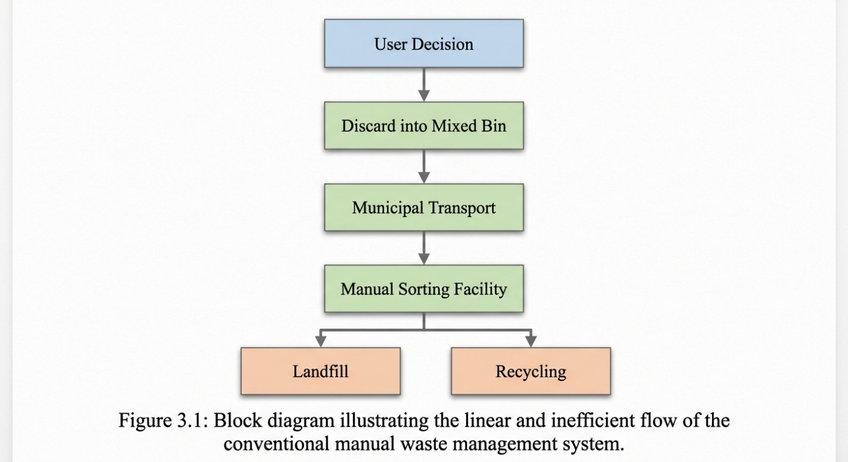
Figure 3.1: Block diagram illustrating the linear and inefficient flow of the conventional manual waste management system.
As shown in the flow above, the current system delays the sorting process until the very end. By the time the waste reaches the manual sorting facility, organic waste has often contaminated the recyclable paper and cardboard, rendering them useless. There is no data collected at the source regarding who threw the waste or what it was.
3.4. WHAT’S NEW IN THE SYSTEM TO BE DEVELOPED
To fix the flaws in the existing systems, our team introduced two major architectural changes that make our project unique:
3.4.1. SWITCHING FROM IMAGE CLASSIFICATION TO OBJECT DETECTION (YOLOV8)
Instead of trying to guess the whole image, we implemented the YOLOv8 (You Only Look Once) architecture. This allows our camera to process a messy, real-world frame and draw independent bounding boxes around multiple items at once. If a user drops a handful of mixed garbage, our Python backend detects the plastic wrapper, the banana peel, and the medical waste independently in milliseconds. It then translates these specific items into our four main bin categories (Organic, Recyclable, Hazardous, E-waste) and signals the Arduino to actuate the correct servos.
3.4.2. THE CIRCULAR ECONOMY WEB DASHBOARD
Existing systems treat waste disposal as a chore. We are introducing a software ecosystem to turn it into a rewarding habit. We integrated a web backend (using MERN/Next.js) that talks directly to our AI script. Now, the Data Flow Diagram is circular. A user scans a QR code on the bin to link their profile. When the YOLO model detects a recyclable item and the Arduino opens the bin, the Python script sends an HTTP request to our database. The user instantly receives "Circular Economy" reward points on their dashboard. This bridges the gap between IoT hardware, Edge AI, and full-stack web development to create a measurable recycling incentive.
4. PROBLEM ANALYSIS
4.1. PRODUCT DEFINITION
Our product is a hybrid hardware-software solution designed to automate waste segregation and reward users for recycling. It consists of two main environments: the physical edge device and the cloud-based web application.
The physical product is a multi-compartment smart bin. It uses a standard 720p webcam mounted above the disposal area to capture live video frames of the waste. A local computer or edge device runs a Python script powered by the YOLOv8 object detection model to identify the specific waste items in the frame. Once identified, the Python script communicates via a serial connection to an Arduino Uno, which then triggers standard servo motors to open the correct physical compartment (Organic, Recyclable, Hazardous, or E-waste).
The software product is a web-based "Circular Economy" dashboard built using the MERN stack (MongoDB, Express, React/Next.js, Node.js). Every time the physical bin successfully categorizes a recyclable item, the Python script sends an HTTP POST request to this backend. The system logs the event and adds reward points to the user's database profile, which they can view on their phone.
4.2. FEASIBILITY ANALYSIS
Before writing the code or buying hardware components, we evaluated whether this project was actually possible for our student team to complete within the final year constraints.
4.2.1. TECHNICAL FEASIBILITY:
We initially worried that running real-time object detection would require expensive Nvidia GPUs. However, we found that YOLOv8 Nano (yolov8n) is lightweight enough to run effectively on standard laptop CPUs at an acceptable frame rate. On the web development side, our team is already familiar with JavaScript and the MERN stack, making the dashboard and API integration technically feasible without a massive learning curve.
4.2.2. ECONOMIC FEASIBILITY:
Building industrial sorting machines costs lakhs of rupees, which is completely out of budget for a student project. Our design is highly economically feasible because we use off-the-shelf, low-cost components. An Arduino Uno, basic 9G or MG995 servo motors, and a standard USB webcam keep the hardware prototype budget very low. The software relies entirely on open-source frameworks (Python, PyTorch, Node.js) and free cloud database tiers (like MongoDB Atlas), resulting in zero software licensing costs.
4.2.3. OPERATIONAL FEASIBILITY:
For this system to work in the real world, users must actually want to use it. If the process is too slow, students will just drop their trash on the floor. By keeping the YOLO inference time under a few milliseconds, the bin opens almost instantly. The QR-code scanning process for the web dashboard takes less than two seconds, ensuring the system integrates smoothly into a busy university hallway without causing foot-traffic jams.
4.3 PROJECT PLAN
We structured the development over a 14-week timeline to ensure we had enough time to pivot when things went wrong (such as our early failure with standard image classification).
- Week 1–2: Conducted literature review and feasibility study. Tested basic ultrasonic sensor bins and realized they do not actually segregate waste.
- Week 3–4: Pivoted to computer vision. Tested MobileNetV2 and realized it fails with multiple objects. Decided to switch the entire architecture to YOLOv8 object detection.
- Week 5–6: Downloaded the correct bounding-box waste dataset from Roboflow. Trained the YOLOv8 model and tuned hyperparameters to improve accuracy on items like crushed plastic bottles.
- Week 7–8: Built the physical bin prototype. Wired the Arduino, webcam, and servo motors. Wrote the serial communication logic between Python and Arduino.
- Week 9–10: Developed the MERN/Next.js backend and API routes. Built the frontend dashboard for users to track their "Circular Economy" points.
- Week 11–12: Full system integration. Connected the Python YOLO script to the web API to automatically push points when the Arduino actuates the Recyclable bin.
- Week 13–14: Final testing and debugging. We fixed major issues during this phase, such as servo motor jitter caused by the Python script sending too many rapid signals, and lighting issues with the webcam. Compiled the final capstone report.
5. SOFTWARE REQUIREMENT ANALYSIS
5.1 INTRODUCTION
This chapter outlines the exact hardware and software environments required to build and run the "AI-Driven Smart Waste Management and Circular Economy System." Because our project acts as a bridge between machine learning, embedded IoT hardware, and full-stack web development, we had to carefully select tools that could communicate with each other in real-time without causing system lag.
5.2 GENERAL DESCRIPTION
Our system does not operate on a single platform. It requires three distinct operating environments. First, we need a local runtime environment capable of processing heavy video feeds and running neural network inference. Second, we need a microcontroller environment to handle low-level electrical signals for the physical bin mechanism. Third, we need a cloud-hosted web environment to manage user accounts and the circular economy points database. We selected open-source technologies for all three environments to keep the project within budget.
5.3 SPECIFIC REQUIREMENTS
5.3.1 HARDWARE REQUIREMENTS
To physically build the smart bin and run the AI model, we utilized the following hardware components:
- Processing Unit: A standard laptop or PC (Core i5 or equivalent, minimum 8GB RAM) acts as the edge device to run the YOLOv8 model.
- Camera Module: A standard 720p USB Web Camera. We specifically avoided low-quality VGA cameras because the AI needs clear resolution to differentiate between text on a plastic bottle and text on a piece of paper.
- Microcontroller: An Arduino Uno R3 board. This handles the physical logic.
- Actuators: Standard servo motors (such as the SG90 or MG995) to open the physical flaps of the Organic, Recyclable, Hazardous, and E-waste compartments.
- Miscellaneous: A breadboard, jumper wires, and structural materials (cardboard/acrylic) to build the bin chassis.
5.3.2 SOFTWARE REQUIREMENTS
The software stack is divided into the AI inference engine, the microcontroller logic, and the web application.
- Programming Languages: Python (for AI and computer vision), C++ (for Arduino logic), and JavaScript/TypeScript (for the web dashboard).
- AI & Computer Vision Frameworks: * Python 3.8+: The core runtime environment.
  - Ultralytics (YOLOv8): The primary object detection library used to train and run our waste classification model.
  - OpenCV (cv2): Used to capture the live video feed from the webcam and draw the bounding boxes on the screen.
  - PyTorch: The underlying deep learning backend required to run YOLOv8.
- Embedded Software:
  - Arduino IDE: Used to write and flash the C++ code to the Arduino Uno, enabling it to read serial commands sent by the Python script.
- Web Development Stack (Circular Economy Dashboard):
  - Node.js: The runtime environment for our backend server.
  - Next.js / React: Used to build the frontend user interface where users scan their QR codes and check their points.
  - MongoDB: A NoSQL database hosted on MongoDB Atlas to securely store user profiles and their accumulated recycling reward points.
6. DESIGN
6.1 SYSTEM DESIGN
Our system architecture relies on a decoupled, distributed design. We separated the heavy AI processing from the low-level hardware control to ensure the system runs quickly and efficiently.
The design is split into three main nodes:
- The Edge Vision Node: A local processing unit running Python and the YOLOv8 neural network. This node handles the webcam feed, processes the video frames to detect waste, and makes the logical decision about which category the waste belongs to.
- The Hardware Actuation Node: An Arduino Uno connected via USB serial to the Edge Vision Node. It waits for simple string commands (like "O" for Organic or "R" for Recyclable) and translates them into physical movement using servo motors.
- The Web Application Node: A MERN/Next.js stack hosted on the cloud. When the Edge node successfully categorizes an item, it fires an HTTP POST request to this node to update the user's "Circular Economy" reward points in a MongoDB database.
6.2 DESIGN NOTATIONS
For our architectural and data flow diagrams, we utilized standard Unified Modeling Language (UML) and flowchart notations. Rectangles represent active processing steps (like AI inference or API calls), diamonds represent decision logic (checking the confidence score of the YOLO model), and cylinders denote data storage (our MongoDB user profiles). Arrows indicate the strict, one-way flow of data from the physical camera up to the cloud server.
6.3 DETAILED DESIGN
We spent the majority of our design phase figuring out how to make the Python script talk to both the Arduino and the web server simultaneously without crashing.
- The AI Module Design: We designed the YOLOv8 script to read frames at 30 FPS. However, running inference on every single frame causes massive lag. To solve this, we designed a frame-skipping logic where the model only processes every 5th frame. If the confidence score of the detected object is above 60%, it locks in the decision.
- The Serial Communication Design: We had to carefully design the baud rate between Python and Arduino. We initially tried 115200 baud, but the Arduino missed signals and the servos twitched. We lowered the design specification to a stable 9600 baud rate.
- The API Design: The backend features a simple RESTful design. We created an endpoint /api/rewards/add which accepts a JSON payload containing the user's ID and the waste category. The server processes this and increments the user's score by 10 points for recyclables.
6.4 FLOWCHARTS
To visualize the real-time logic, we developed the following control flow.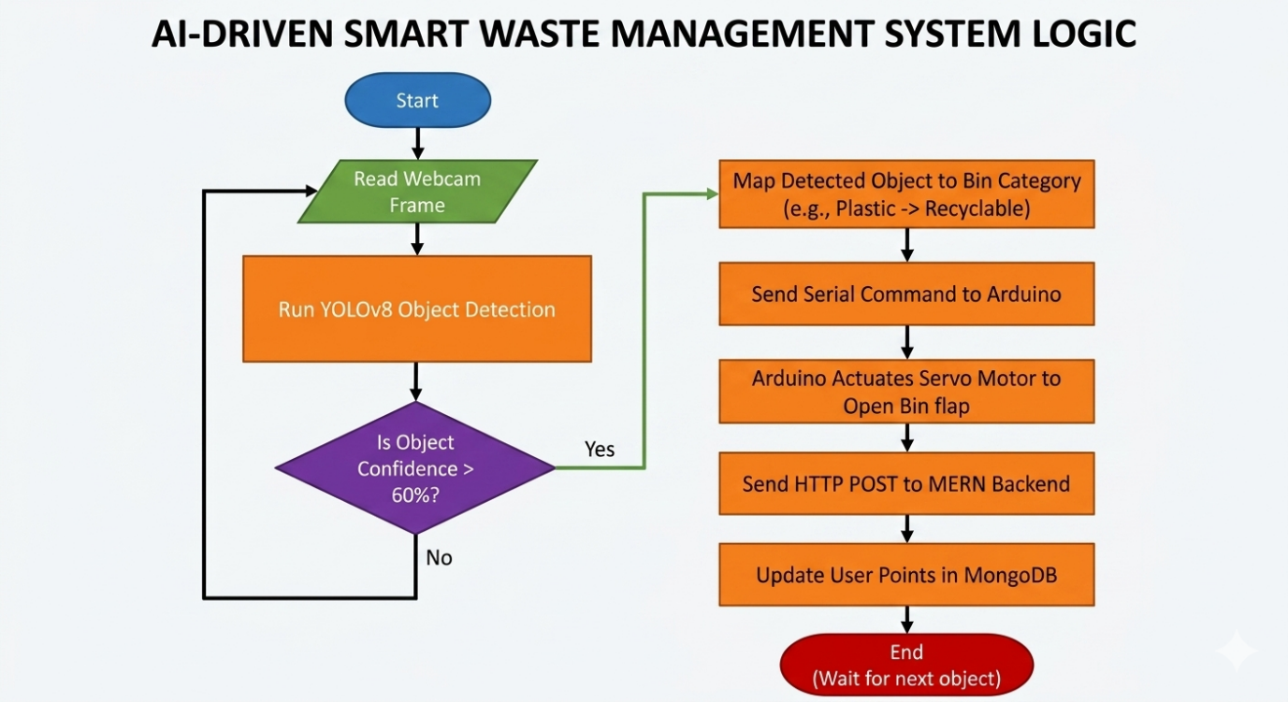
Figure 6.1: Flowchart illustrating the real-time processing logic, AI inference, hardware actuation, and web API integration of the edge device.
6.5 PSEUDO CODE
To ensure our logic was sound before writing the actual syntax, we broke our system down into two main algorithms. Algorithm 1 handles the local edge processing (Camera, AI, and Arduino). Algorithm 2 handles the cloud-based reward system (Node.js backend).
Algorithm 1: Edge AI Inference and Hardware Control (Python)
This algorithm runs constantly on the local machine attached to the smart bin.
# =================================================================
# ALGORITHM 1: YOLOv8 Inference and Serial Actuation
# =================================================================
# 1. INITIALIZATION PHASE
# Load the custom weights we generated during our Roboflow training
LOAD YOLOv8_Model USING "best.pt"

# Establish communication with the physical Arduino board
OPEN Serial_Connection TO "COM3" AT baud_rate = 9600

# Turn on the physical webcam
START Webcam_Feed

# 2. MAIN EXECUTION LOOP
WHILE Webcam_Feed IS active:

# Grab the current picture from the camera
CAPTURE current_frame

# Pass the picture to our AI model to find waste
DETECTED_OBJECTS = YOLOv8_Model.predict(current_frame)

# Only proceed if the AI actually found something
IF length_of(DETECTED_OBJECTS) > 0:

FOR EACH object IN DETECTED_OBJECTS:
GET item_name # e.g., "plastic_bottle"
GET confidence_score # e.g., 0.85 (85% sure)

# 3. FILTERING AND LOGIC
# Ignore bad predictions to prevent the bin from opening by mistake
IF confidence_score > 0.60:

# Check our custom dictionary to see which bin this belongs to
bin_category = CHECK_MAPPING_DICTIONARY(item_name)

# 4. HARDWARE ACTUATION & CLOUD SYNC
IF bin_category == "Recyclable":
SEND_SERIAL("R") # Tell Arduino to open Recyclable servo

# Reward the user for recycling by calling our web API
HTTP_POST("https://our-backend.com/api/add-points", user_id, +10)

ELSE IF bin_category == "Organic":
SEND_SERIAL("O") # Tell Arduino to open Organic servo

ELSE IF bin_category == "Hazardous":
SEND_SERIAL("H") # Tell Arduino to open Hazardous servo

ELSE IF bin_category == "E-waste":
SEND_SERIAL("E") # Tell Arduino to open E-waste servo

# Halt the script temporarily so the physical flap has time to open and close
WAIT 3 seconds

# Show the live video feed with bounding boxes drawn on the screen
DISPLAY current_frame

# Allow the admin to safely shut down the system
IF user_presses_key == 'Q':
BREAK WHILE LOOP

# Cleanup hardware resources
STOP Webcam_Feed
CLOSE Serial_Connection
END ALGORITHM
Algorithm 2: Circular Economy Reward Logic (Node.js / Express)
This algorithm runs on our cloud server and listens for requests coming from the Python script.
# =================================================================
# ALGORITHM 2: Web API for Circular Economy Points
# =================================================================

# Wait for a POST request from the Python Edge Node
LISTEN ON ENDPOINT "/api/add-points":

# Extract the data sent by the Python script
RECEIVE request_payload
GET target_user_id FROM request_payload
GET points_to_add FROM request_payload

# Safety check: Ensure the request contains the right data
IF target_user_id IS NULL OR points_to_add <= 0:
RETURN HTTP_STATUS 400 (Bad Request)

TRY:
# Search our MongoDB database for this specific user
FIND user IN MongoDB WHERE _id == target_user_id

IF user EXISTS:
# Add the new points to their existing total
NEW_TOTAL = user.current_points + points_to_add
UPDATE user.current_points = NEW_TOTAL IN MongoDB

RETURN HTTP_STATUS 200 (Success, Points Added)
ELSE:
RETURN HTTP_STATUS 404 (User Not Found)

CATCH database_error:
# If MongoDB crashes, log the error so we can fix it later
LOG database_error
RETURN HTTP_STATUS 500 (Internal Server Error)

END ALGORITHM

7. TESTING
7.1 INTRODUCTION
Testing was the most time-consuming phase of our project. Because our system connects a physical Arduino board, a Python AI model, and a cloud database, a failure in one area caused the entire system to crash. We broke our testing down into software functionality, hardware structure, and full system integration.
7.2 FUNCTIONAL TESTING
We tested the two main software modules separately before connecting them.
- YOLOv8 AI Testing: We started by testing the trained YOLOv8 model using a reserved set of images from our Roboflow dataset that the model had never seen before. We also tested it live using the webcam. We held up various items like crushed plastic bottles, torn cardboard, and fresh fruit. We logged the confidence scores. If the model guessed below 50% confidence, we considered it a failed test.
- Web API Testing: We used Postman to test the Node.js backend. We sent fake HTTP POST requests to our /api/add-points endpoint to see if the MongoDB database would correctly update a user's score. We checked edge cases, like what happens if we send a negative point value or an invalid user ID.
7.3 STRUCTURAL TESTING
Structural testing focused on the physical build and the data pathways.
- Serial Communication Test: We wrote a basic Python script that just sent the letters "R", "O", "H", and "E" to the Arduino via the COM port to see if the correct servo motor moved.
- Mechanical Test: We tested the physical flaps of the bin by dropping heavy items (like a glass bottle) and light items (like a single piece of paper) to ensure the servos had enough torque to open the flap and the structural material wouldn't break.
7.4 LEVELS OF TESTING
- Unit Testing: We tested isolated blocks of code, such as the specific Python function that crops the center of the webcam frame.
- Integration Testing: We tested the connection between the Edge Vision Node (Python) and the Cloud Node (Next.js/MongoDB).
- System Testing: We ran the entire loop from start to finish. A team member scanned their QR code, dropped a bottle, watched the bin open, and checked their phone to see if the points arrived.
7.5 TESTING THE PROJECT: CHALLENGES AND BUG FIXES
During the testing phase, things did not work perfectly on the first try. We faced several major bugs that forced us to rewrite parts of our code and adjust our hardware.
Bug 1: The Bouncing Servo Issue When we first connected the YOLO model to the Arduino, the servos twitched uncontrollably. We realized that because the Python script processes video at 30 frames per second, it was sending the "Open Bin" command 30 times a second to the Arduino. The Arduino buffer overflowed and crashed. To fix this, we wrote a "debounce" logic in Python. Once the AI detects an object and sends the command, we force the script to pause (time.sleep(3)) so the bin has time to open, drop the waste, and close before reading the next frame.
Bug 2: Lighting and Glare We noticed the YOLO model performed terribly at night or under the bright fluorescent lights of the university hallway. Glare on plastic wrappers made them look completely white to the webcam. We solved this by physically attaching a small LED strip inside the sorting chamber of the bin to provide consistent, even lighting regardless of the outside environment.
Bug 3: The CORS Web Error When we finally tried to send the HTTP request from our local Python script to our hosted Node.js server, the server blocked the request. We hit a standard CORS (Cross-Origin Resource Sharing) error. We had to go back into our Express.js backend code and explicitly allow POST requests coming from our local edge device's IP address.
Bug 4: Confusing Crumpled Paper During live testing, the YOLO model kept classifying heavily crumpled white paper as "Plastic Bottle." We realized our Roboflow training dataset only contained pictures of flat paper. We had to manually take 50 pictures of crumpled paper, draw bounding boxes around them, upload them to the dataset, and retrain the best.pt weights.
8. IMPLEMENTATION
8.1 IMPLEMENTATION OF THE PROJECT
Moving from our software design to a physical, working prototype required us to implement the project in three distinct phases: Hardware Assembly, AI Deployment, and Web Integration.
First, we implemented the hardware chassis. We constructed a custom bin with four separate compartments. We mounted four standard servo motors to the flap of each compartment and wired them directly to the digital pins of our Arduino Uno. We then mounted a 720p USB webcam directly above the disposal area, pointing downwards, and connected it to our edge processing laptop via USB.
Second, we deployed the AI model. Instead of writing a neural network from scratch, we utilized the ultralytics YOLOv8 framework. We downloaded our mapped waste dataset from Roboflow, containing thousands of images with pre-drawn bounding boxes. We ran the training script locally for 30 epochs. Once the best.pt weights file was generated, we integrated it into our main Python script using the OpenCV library (cv2) to capture the live webcam feed and run real-time inference.
Finally, we implemented the web backend to manage the Circular Economy points. We created a Node.js server using Express and connected it to a free MongoDB Atlas cloud cluster. We wrote a specific API route that listens for incoming data from our Python script. Once everything was running, we linked the Python logic to the web logic using the requests library in Python, ensuring that every time the "Recyclable" servo opened, the database updated the user's score.
8.2 CONVERSION PLAN
If a university or corporate tech park wants to adopt our smart waste system, they cannot simply remove all old bins overnight. We recommend a "Parallel Run" conversion plan.
In this plan, the administration will install our AI Smart Bins directly next to the traditional green and blue dustbins in high-traffic areas, like cafeterias or main hallways. We will place a large QR code on the front of our smart bin with instructions explaining that students can earn reward points by throwing their recyclables in the new system. Over a period of one month, as students download the web app and realize they can earn rewards, the administration can slowly phase out the old, unmonitored bins. This parallel approach ensures that if our prototype requires maintenance, students still have a place to throw their garbage.
8.3 POST-IMPLEMENTATION AND SOFTWARE MAINTENANCE
Software and hardware maintenance is critical for this project because the physical environment changes constantly.
On the software side, the most important maintenance task is addressing "model drift." Packaging designs change all the time. If a company releases a new energy drink with a completely different bottle shape, our YOLOv8 model might not recognize it as a recyclable item. To maintain high accuracy, an administrator must collect images of new waste items every 3 to 6 months, upload them to the Roboflow dataset, and retrain the model to generate an updated weights file.
On the hardware side, servo motors undergo heavy mechanical stress. We noticed during implementation that if a user drops a heavy glass bottle directly onto a closed flap, the servo gears can strip. Routine hardware maintenance requires checking the torque of the motors and replacing any jammed servos. Finally, the MongoDB database will require periodic cleanup to archive old user data and prevent cloud storage limits from being exceeded.
9. PROJECT LEGACY
9.1 CURRENT STATUS OF THE PROJECT
Our team has successfully built a working, scaled-down prototype of the smart bin and the web ecosystem. Right now, the physical unit sits in our workspace and operates as intended. The YOLOv8 model actively scans the webcam feed, accurately draws independent bounding boxes around test waste, and the Arduino Uno successfully translates those predictions into physical servo movements. Also, the web integration is fully live. If a user drops a plastic bottle into the camera's view, the Next.js dashboard updates their Circular Economy reward points within a few seconds. We successfully bridged the gap between embedded IoT, edge AI, and full-stack web development.
9.2 REMAINING AREAS OF CONCERN
Despite the working prototype, we still have a few major concerns that need to be addressed before this system could be mass-produced for a real university hallway.
First, the physical durability needs a massive upgrade. The lightweight materials and basic hobby servos we used for the prototype lack the torque to handle heavy, wet garbage or physical abuse from users over long periods.
Second, overlapping waste is a physical limitation of computer vision. If someone throws a piece of paper directly on top of a battery, the camera only sees the paper. The YOLOv8 model cannot see through solid objects, which means the hazardous battery might accidentally end up in the recyclable bin.
Finally, our current code requires a constant Wi-Fi connection. If the campus internet drops, the Python script hangs when it tries to send the HTTP POST request to our cloud server. This timeout completely halts the physical bin mechanism, preventing people from throwing away their trash until the internet comes back.
9.3 TECHNICAL AND MANAGERIAL LESSONS LEARNT
We learned a massive amount from the mistakes we made during the last few months of development.
Technical Lessons: The most important technical lesson was understanding the strict difference between image classification and object detection. We wasted weeks trying to force our initial architecture to sort mixed garbage before realizing we absolutely needed YOLOv8's bounding-box approach. We also learned how difficult hardware-software integration actually is. Building a clean web dashboard in React/Next.js is straightforward, but making a Python script talk to a physical Arduino board over a serial port without overflowing the microcontroller's memory buffer was a completely new challenge for us.
Managerial Lessons: We learned the hard way that system integration always takes twice as long as planned. We originally gave ourselves one week to connect the Python AI to the Next.js database, but debugging network issues and cross-origin resource sharing (CORS) blocks took much longer. We also learned how to scope a project properly. At the start of the year, we had ambitious plans to build a city-wide waste tracking system. We quickly realized that engineering one single, highly reliable edge device was a much smarter and more realistic capstone goal.
10. USER MANUAL
10.1 INTRODUCTION
This manual provides a complete help guide for operating the AI-Driven Smart Waste Management and Circular Economy System. Because the project consists of both physical hardware and a web dashboard, we have divided this guide into instructions for the general user and setup instructions for the system administrator.
10.2 END-USER GUIDE (HOW TO EARN POINTS)
For the everyday user, the process is designed to be completely hands-free and take less than five seconds.
Step 1: Account Creation Walk up to the smart bin. You will see a QR code printed on the front panel. Scan this QR code using your smartphone camera. It will direct you to our Next.js Circular Economy dashboard. Click "Register" and create a free account using your university email address.
Step 2: Linking to the Bin Once logged in, click the "Ready to Dispose" button on your phone screen. The screen will display a temporary 4-digit PIN. Keep this PIN active on your screen.
Step 3: Disposing of Waste Place your waste item (e.g., a plastic bottle or an apple core) flat on the scanning platform directly under the webcam. Make sure your hand is not covering the item.
Step 4: Mechanical Sorting Wait approximately 2 to 3 seconds. The YOLOv8 model will scan the item, and you will hear a beep from the Arduino. The correct servo motor will rotate, opening the flap, and your waste will drop into the designated compartment.
Step 5: Earning Rewards Check your smartphone. If the item you threw away was categorized as "Recyclable," the dashboard will automatically refresh and add 10 Circular Economy points to your profile. You can view your total points history on the home tab.
10.3 SYSTEM ADMINISTRATOR GUIDE (HARDWARE AND SOFTWARE SETUP) If the system shuts down or needs to be restarted, the administrator must follow these steps to bring the edge device and web server back online.
Step 1: Hardware Connections
Ensure the Arduino Uno is connected to the laptop or Raspberry Pi via the USB cable. Ensure the 720p webcam is plugged into a high-speed USB 3.0 port. Check that the servo motor power lines are connected to the 5V rail on the breadboard.
Step 2: Starting the Cloud Database
The MongoDB server runs automatically on the cloud. However, you need to start the Node.js API to allow point transactions. Open your terminal, navigate to the backend folder, and type: npm start Wait for the message: "Server is running on port 5000."
Step 3: Starting the Edge AI Inference
Open a second terminal window and navigate to the folder containing your Python scripts and the best.pt YOLOv8 weights file. Type the following command: python predict.py A window will pop up showing the live video feed from the webcam. The system is now active and ready to process waste.
10.4 TROUBLESHOOTING GUIDE
- Issue: The camera window does not open when running the Python script.
  - Fix: Check the webcam index in the code. It is usually cv2.VideoCapture(0). If you have multiple cameras plugged in, change the 0 to a 1.
- Issue: The servo motors twitch but the flap does not open.
  - Fix: The Arduino is likely receiving too much power draw from the servos. Check the external 5V power supply attached to the breadboard. Do not power four heavy servos directly from the Arduino's 5V pin, or the board will reset.
- Issue: Bounding boxes appear on the screen, but points do not update on the web app.
  - Fix: The Python script has lost connection to the internet. Check the Wi-Fi connection on the edge device to ensure the HTTP POST requests are reaching the Node.js server.

11. SOURCE CODE AND SYSTEM SNAPSHOTS
11.1 INTRODUCTION
This section contains the core source code responsible for the YOLOv8 object detection, serial communication, and the backend logic for the Circular Economy reward system.
11.2 EDGE AI INFERENCE CODE (PYTHON)
The following script runs on the local edge device. It captures the webcam feed, processes the frame using our trained YOLOv8 model, maps the detected item to the correct bin, and sends a signal to the Arduino.
import cv2
import time
import requests
import serial
from ultralytics import YOLO

# Initialize Arduino Serial Connection
try:
arduino = serial.Serial(port='COM3', baudrate=9600, timeout=.1)
except:
print("Warning: Arduino not connected on COM3")

# Load YOLOv8 weights trained on Roboflow Waste Dataset
MODEL_PATH = "runs/detect/train/weights/best.pt"
model = YOLO(MODEL_PATH)

# Define the Circular Economy API endpoint
API_URL = "http://localhost:5000/api/add-points"
CURRENT_USER_ID = "student_12345" # Example ID scanned from QR

# Map specific items to general bins
BIN_MAPPING = {
"Recyclables - plastic bottle": "Recyclable",
"Recyclables - can": "Recyclable",
"Kitchen waste - fruit": "Organic",
"Hazardous waste - battery": "Hazardous"
}

cap = cv2.VideoCapture(0)

while True:
ret, frame = cap.read()
if not ret:
break

# Run detection with 60% minimum confidence
results = model.predict(source=frame, conf=0.6, show=False)

for box in results[0].boxes:
class_id = int(box.cls[0].item())
item_name = model.names[class_id]

bin_category = BIN_MAPPING.get(item_name, "Unknown")

if bin_category != "Unknown":
# Send command to Arduino to open specific servo
if bin_category == "Recyclable":
arduino.write(bytes('R', 'utf-8'))
# Add 10 reward points to the user's dashboard
requests.post(API_URL, json={"userId": CURRENT_USER_ID, "points": 10})

elif bin_category == "Organic":
arduino.write(bytes('O', 'utf-8'))

# Pause to allow the physical bin to open and close
time.sleep(3)

cv2.imshow("Smart Bin - Live Detection", frame)

if cv2.waitKey(1) & 0xFF == ord('q'):
break

cap.release()
cv2.destroyAllWindows()
11.3 WEB BACKEND CODE (NODE.JS/EXPRESS)
This code snippet represents the cloud backend. It listens for the HTTP POST request triggered by the Python script and updates the MongoDB database.
JavaScript
const express = require('express');
const mongoose = require('mongoose');
const app = express();

app.use(express.json());

// Define the User Database Schema
const UserSchema = new mongoose.Schema({
userId: String,
points: Number
});
const User = mongoose.model('User', UserSchema);

// API Route to add Circular Economy points
app.post('/api/add-points', async (req, res) => {
const { userId, points } = req.body;

try {
let user = await User.findOne({ userId: userId });
if (user) {
user.points += points;
await user.save();
res.status(200).json({ message: "Points added successfully", totalPoints: user.points });
} else {
res.status(404).json({ error: "User not found" });
}
} catch (error) {
res.status(500).json({ error: "Database transaction failed" });
}
});

app.listen(5000, () => console.log('Reward Server running on port 5000'));
11.4 SYSTEM SNAPSHOTS
[Note to student: Take a screenshot of the YOLO model running on your webcam with a green box around a plastic bottle. Insert it here.] Figure 1: Real-time Object Detection using YOLOv8
[Note to student: Take a screenshot of your Next.js Web Dashboard showing a user profile and their reward points. Insert it here.] Figure 2: Circular Economy Web Dashboard Interface
[Note to student: Take a picture of your physical hardware (the Arduino connected to the servos and webcam). Insert it here.] Figure 3: Hardware Integration and Servo Assembly
12. BIBLIOGRAPHY
[1] Jocher, G., Chaurasia, A., & Qiu, J. (2023). Ultralytics YOLOv8. GitHub repository. Retrieved from https://github.com/ultralytics/ultralytics
[2] Roboflow Universe. (2024). Waste Detection Dataset. Retrieved from https://universe.roboflow.com/
[3] Vercel. (2024). Next.js Documentation: The React Framework for the Web. Retrieved from https://nextjs.org/docs
[4] MongoDB, Inc. (2024). MongoDB Atlas Cloud Database Documentation. Retrieved from https://www.mongodb.com/docs/atlas/
[5] Arduino. (2024). Arduino Uno R3 Official Documentation and Serial Communication Reference. Retrieved from https://docs.arduino.cc/hardware/uno-rev3
[6] Paszke, A., Gross, S., Massa, F., & Lerer, A. (2019). PyTorch: An Imperative Style, High-Performance Deep Learning Library. Advances in Neural Information Processing Systems 32.

